**CHAPTER 2**

**BONDING**

**Causes of Bonding**

Atoms of most elements form bonds with one another in order to achieve the electronic configuration of a noble gas which is more stable. The atoms can achieve this stable configuration in the following three ways:

1. By loosing one or more electrons to another atom
2. By gaining one or more electrons from another atom
3. By sharing one or more electrons with other atoms

**Classification of bonds**

The bonds are broadly classified into the following two types:

1. Primary bonds
2. Secondary bonds

**Primary bonds**

A primary bond is an interatomic bond in which electrostatic force holds the atoms together. It is stronger and more stable

**Secondary bonds**

A Secondary bond is an intermolecular bond in which weak forces hold the molecules together. The weak forces are known as van der Waal’s forces. A secondary bond is weak and less stable than a primary bond.

**Types of Primary bonds**

1. Ionic bonds
2. Covalent bonds
3. Metallic bonds

**Ionic bonds**

An ionic bond is formed when one or more electrons from the outermost shells of one atom are transferred to the outermost shell of another atom. Both atoms acquire the electronic configuration of a noble gas. Both atoms become oppositely charged. The electrostatic attraction between the oppositely charged ions forms the ionic bond.

**Properties of ionic solids**

1. They are rigid, unidirectional and crystalline in nature
2. They are bad conductors of electricity in their solid state
3. They are good conductors of electricity in their molten state
4. They have high melting and boiling temperatures
5. They are freely soluble in water abut slightly soluble in organic solvent

**Covalent bonds**

A covalent bond is formed when two or more electrons of an atom in its outermost energy level are shared by electrons of other atoms. The sharing of atoms takes place in such a way that each atom in the resulting molecule gets a stable configuration. E.g O2, Cl2, H2, N2, CH4 etc

**Properties of Covalent solids**

1. They are bad conductors of electricity
2. Covalent compounds have low melting and boiling temperatures
3. Covalent compounds are not soluble in water but are soluble in organic solvents such as benzene, toluene etc

**Metallic bonds**

In all the metal atoms, the electrons in the outermost energy levels are loosely held by their nuclei. As a result of this, all the electrons in the outermost energy levels require a very small amount of energy to detach themselves from their nuclei. At room temperature, all the metal atoms lose electrons from their outermost energy levels, which form an electron cloud or common pool of electrons. The atoms, after loosing their outermost electrons, acquire positive charges and become positive ions.

Thus, a metal may be considered as a cluster of positive ions surrounded by a large number of free electrons forming electron gas or electron cloud as shown below.

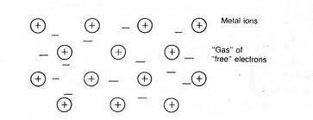

The electrostatic force of attraction between the electron cloud and positive ions constitute the metallic bond.

**Properties of metallic solids**

1. They have high electrical and thermal conductivities
2. They have bright luster
3. They are malleable and ductile
4. **In comparison with ionic solids**, they have low melting and boiling temperatures

**Types of secondary bonds**

1. Dispersion bonds
2. Dipole bonds
3. Hydrogen bonds

**CHAPTER 3**

**CRYSTAL DEFECTS OR IMPERFECTIONS**

Crystals are rarely perfect. There are three categories of crystal defects i.e.,

1. Point defects
2. Line defects
3. Surface defects
4. **POINT DEFECTS**

These are the defects which occur due to imperfect packing of atoms during crystallization or due to vibrations of atoms at high temperatures. They include;

1. **Vacancy/ vacancies defect**

They occur whenever one or more atoms are missing from a normally occupied position.

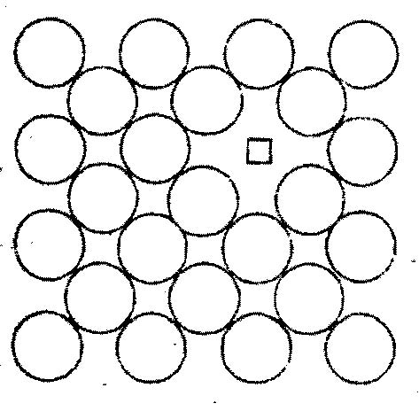

1. **Substitutional defect**

It occurs whenever a foreign atom (other than the parent atoms) occupies a position which was initially meant for a parent atom. The foreign atom may be slightly smaller or larger than the parent atom.

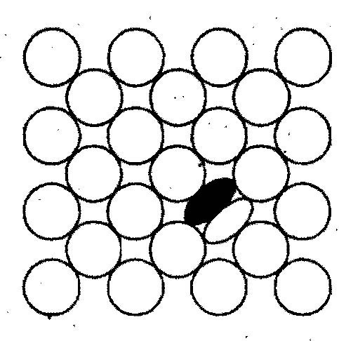

1. **Interstitial defect**

It occurs whenever a foreign atom occupies an interstitial position / void in the crystal without dislodging the parent atom. The foreign atom is usually smaller than the parent atoms.

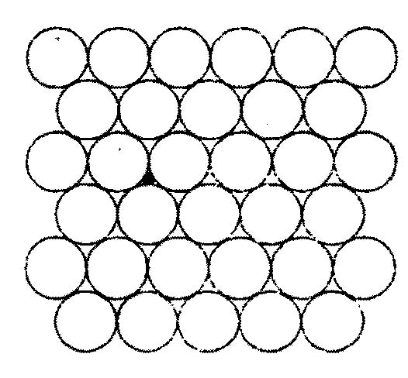

1. **Schottky defect**

It occurs whenever a pair of positive and negative ions is missing from a crystal. The crystal remains electrically neutral after this defect.

1. **Frenkel defect**

It occurs when a positive ion moves into an interstitial position. It occurs in ionic crystals. Electrical neutrality is maintained.

1. **Phonon**

It occurs whenever a **group** of atoms is displaced from its ideal location. It is caused by thermal vibrations.

1. **LINE DEFECTS**

These are the defects which occur due to dislocation or distortion of atoms along a line. They include;

1. **Edge dislocation**

It occurs whenever a half plane of atoms is inserted between the planes of atoms in a perfect crystal.

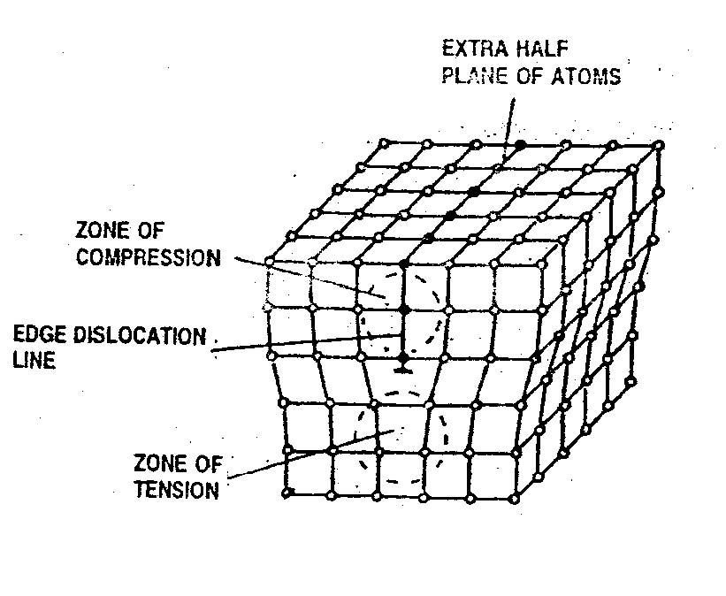

1. **Screw dislocation**

This is a dislocation caused by applying upward and downward shear stress to a region of a crystal that has been separated by a cutting plane.

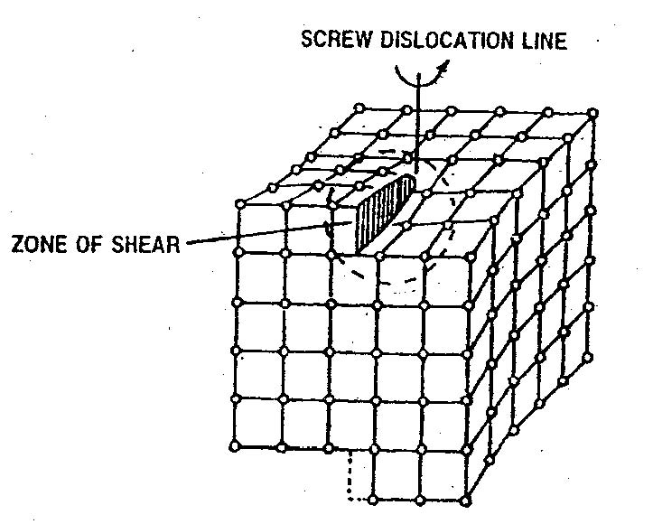

1. **SURFACE DEFECTS**

These are the defects which occur on the surface of a material. They are also known as plane defects. They occur due to imperfect packing of atoms during crystallization or due to defective orientation of the surface. They include;

1. **Grain boundary**

This is the boundary that separates two neighbouring crystals.

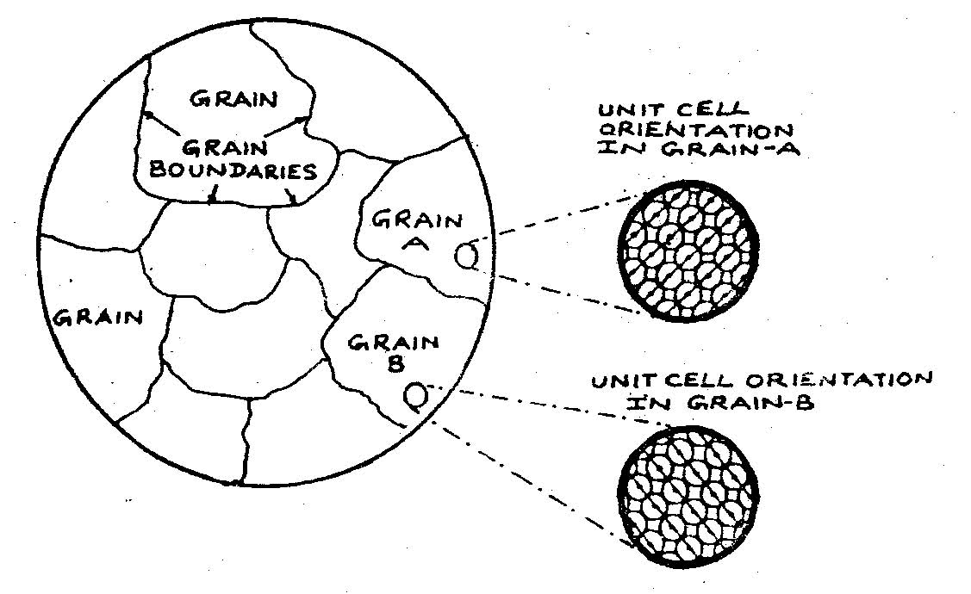

1. **Twin boundary**

This is a grain boundary in which, the arrangement of atoms on one side of the boundary is somewhat a mirror image of the arrangement of atoms on the other side of the boundary

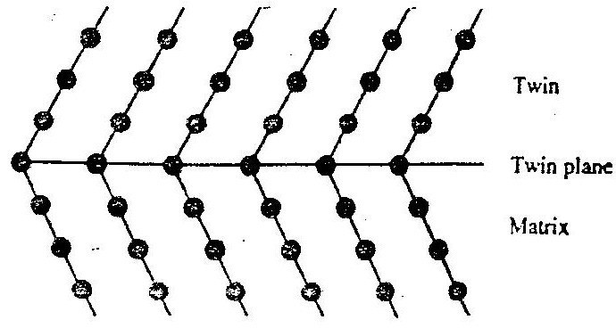

1. **Stacking fault**

It occurs whenever the stacking of the layers of atoms is not in the proper sequence throughout the crystal

****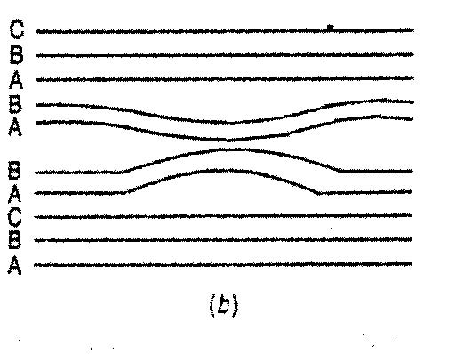

The figure (a) above shows the proper sequence of atomic planes if we read from bottom to top i.e., A-B-C-A-B-C-A-B-C. Figure (b) shows the arrangement of atomic planes when the material has a stacking fault. (A-B-C-A-B-A-B-A-B-C).

**CHAPTER 4**

**TYPES OF MECHANICAL TESTS**

1. Tensile test
2. Compressive test
3. Impact test
4. Hardness test
5. Fatigue test
6. Creep test
7. **Tensile test**

The tensile test for a ductile material is generally carried out with the help of a universal testing machine, on the specimen made from the material to be tested.

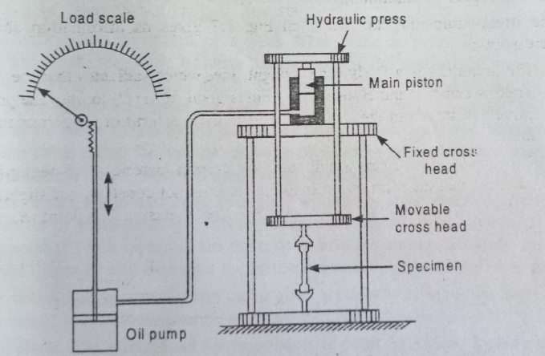

**Figure 1 universal testing machine**

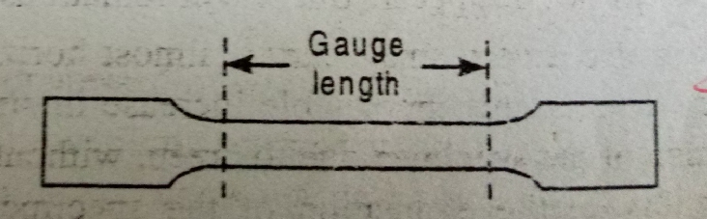

**Figure 2 Specimen for tensile test**

Gauge length Lo=5do (This means for a gauge length of 50mm, the specimen diameter should be 10mm)

1. The test is carried out on a specimen having uniform cross section throughout the gauge length.
2. The specimen is held in the jaws of the machine and the load is applied gradually by a hydraulic press. The tensile load is gradually increased and the corresponding extensions are recorded.
3. The loads are divided by the original cross-sectional area to obtain the stresses whereas the extensions are divided by the original length to obtain the corresponding strain
4. A graph is plotted with stresses along the vertical axis and the corresponding strains along the horizontal axis. Such a graph is known as stress-strain curve for the given ductile material.

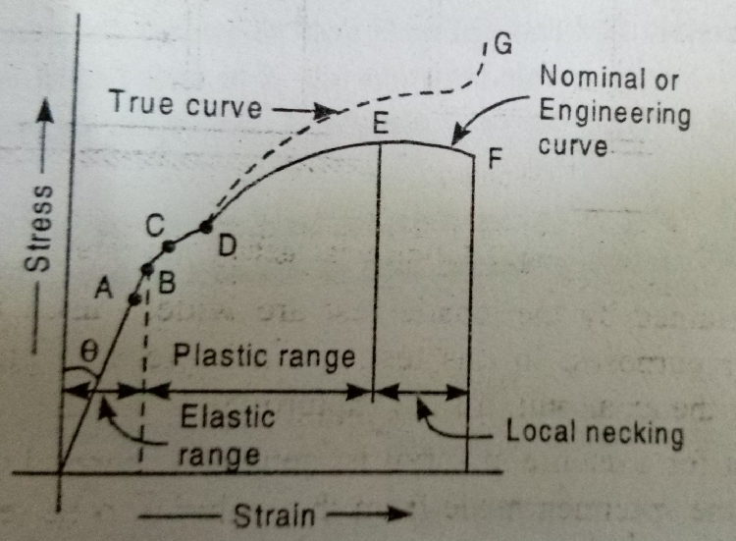

**Figure 3 Stress-strain curve**

The stress strain curve shown in Figure 3 gives us information about the following important points

1. The graph from **origin** to **A** is a fairly long straight line, which indicates that the ratio of stress to strain is constant and the material obeys Hooke’s law. Point **A** where the curve deviates from the straight line is known as **limit of proportionality** or **proportional limit.**
2. The graph **AB** is a very small curve (in certain materials of negligible length), which indicates that the ratio of stress to the strain is not constant, but slightly changes. Point **B is known as elastic point.**
3. The graph **BC** is another very small curve, which indicates that the strain increases more quickly than the stress (in comparison to **OA** or **AB**). Point **C** is called **yield point**. If the load is removed, then the elongation from **B** to **C** will not disappear.
4. The graph **CD** is also a very small curve (almost horizontal), which indicates that the strain increases without any appreciable increase in stress.
5. The graph **DE** is an upward curve, which indicates that the specimen regains some strength and higher values of stresses are required for higher strains. The stress corresponding to **point E** is known as **ultimate tensile stress** or **tenacity** which is a measure of the strength of a material
6. The graph **EF** is a downward curve, which indicates that a neck is formed, which decreases the cross-sectional area of the specimen. Now it requires lesser load to continue extension till fracture takes place at **F**.

The following terms are important in the tensile test of a specimen

1. Elastic stress
2. Yield stress
3. Ultimate stress
4. True stress : It is the load at any instant (called instantaneous load) **divided** by the cross-sectional area of the specimen at that instant (called instantaneous cross-sectional area)
5. Percentage elongation
6. Percentage reduction in area
7. Nominal stress
8. True breaking stress
9. Nominal breaking stress
10. Total elongation = Total increase in length of specimen
11. Modulus of toughness for ductile materials
12. Strain
13. Modulus of elasticity/Young’s modulus

It is the gradient of the straight portion of the stress-strain curve. Usually denoted as E.

**NOTE:** The SI UNITS for stress is N/m2

Strain has no units since it is a ratio of 2 lengths

1. Modulus of resilience

**TUTORIAL QUESTION**

In order to evaluate various mechanical properties, a steel specimen of 12.5mm diameter and 62.5mm gauge length was tested in a standard tension test. The following observations were made during the test;

Yield load =40,000 N

Fracture load =50,500 N

Strain at load of 20,000 N =7.75 X 10-4

Maximum load = 71,500 N

Gauge length at fracture =79.5mm

Determine;

1. Yield point stress
2. Ultimate tensile strength
3. Percentage elongation
4. Modulus of elasticity
5. Fracture stress
6. Modulus of resilience
7. Percentage reduction in area
8. Modulus of toughness
9. **Compressive test**

The compressive test is merely the opposite of the tensile test. It is generally performed for testing brittle materials such as cast iron, concrete, stones etc. The specimens used are usually made of cubical or cylindrical shape

1. **Hardness test**

The hardness test of a metal is generally performed to know its resistance against indentation   
(i.e penetration) and abrasion

**TYPES OF HARDNESS TESTS**

1. Brinell’s hardness test
2. Rockwell hardness test
3. Vicker’s hardness test
4. Knoop’s hardness test
5. **Brinell’s hardness test**

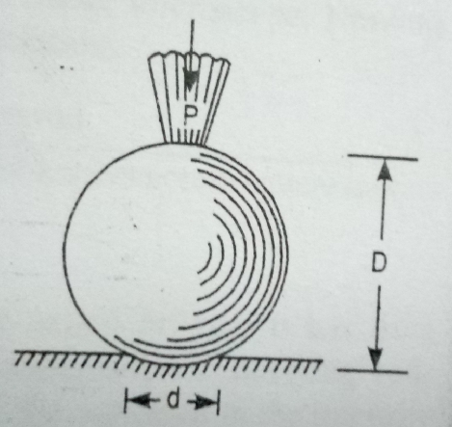

**Figure 4 Brinell’s hardness test**

1. It is performed by pressing a steel ball (known as indentor) into the test piece as shown in **figure** **4.**
2. The mean diameter of the indentation, left on the surface of the specimen, after the removal of the load is measured.
3. The value of hardness of the given material is, mathematically found from the equation:

B.H.N (i.e Brinell’s Hardness Number)

1. **Impact test**

Many machine parts are subjected to suddenly applied loads called impact blows. It has been observed that a metal may be hard, strong or of high tensile strength but may be unsuitable for uses where it is subjected to sharp blows. The capacity of a metal to withstand such blows without fracture is known as **impact resistance** or **impact strength**.

**TYPES OF IMPACT TESTS**

1. Charpy test
2. Izod test
3. **Charpy test**

It is carried on a specimen, which is **55mm x 10mm x10mm** in size and has a **2mm** deep notch making an angle of **45o**as shown in **Figure 5.**

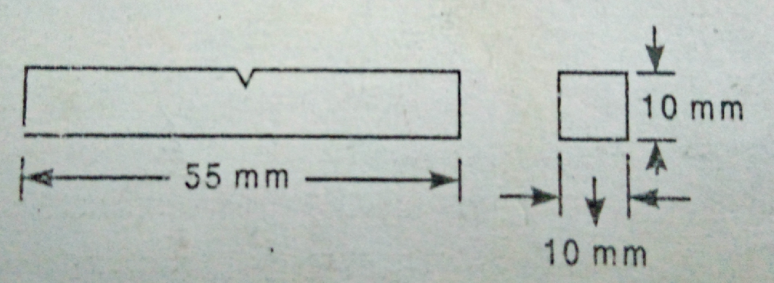

**Figure 5 Specimen for charpy test**

The specimen is placed horizontally between two anvils **40mm** apart such that the striking hammer strikes the specimen on the face which is opposite to the notch as shown in **Figure 6**

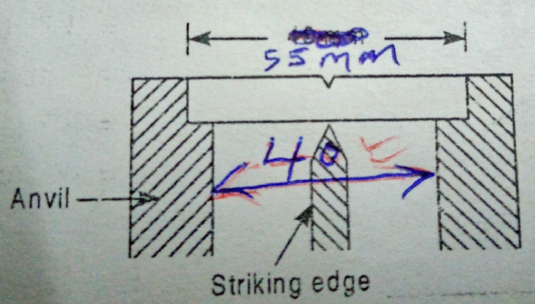

**Figure 6 Specimen between anvils**

The scale of a charpy machine has zero in the vertical line and is graduated on both sides from 0 to the maximum capacity of the machine.

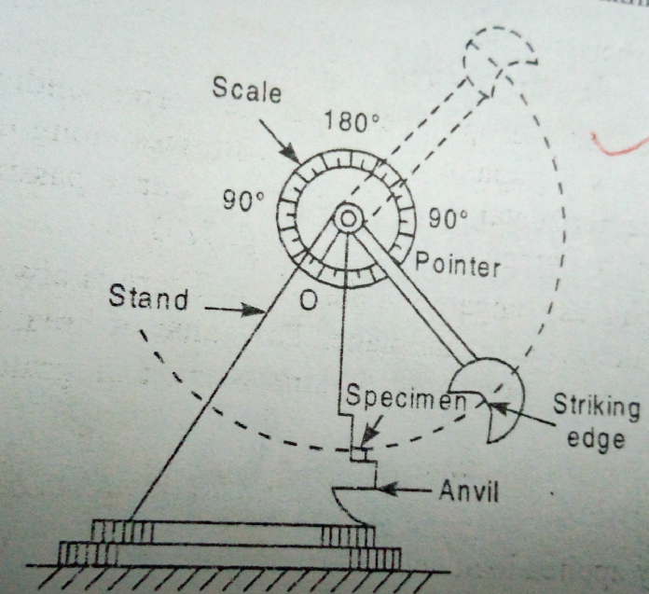

**Figure 7 Charpy test**

The pendulum is released from the right side from a known angle **α**.

The pendulum after breaking the specimen, rises on the opposite side through angle **β**.

The energy absorbed by the specimen during breaking is given by the difference between angle α and β.

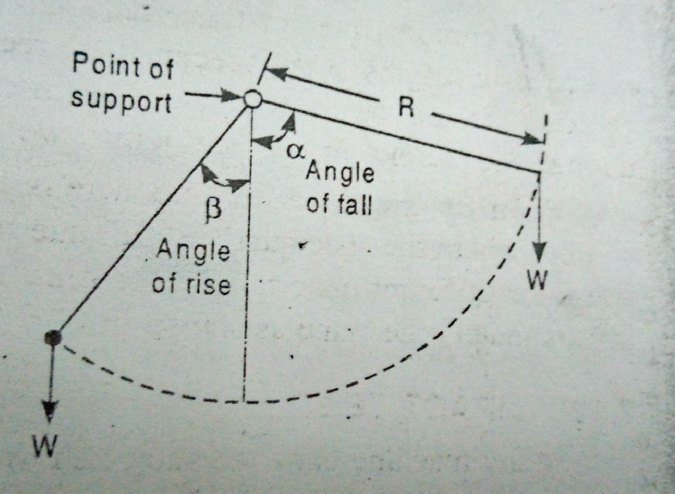

**Figure 8 Energy of pendulum**

Neglecting energy losses,

Let,

W=Weight of pendulum

R= Distance between the centre of gravity of the pendulum and the axis of rotation

From geometry, initial energy of the pendulum = WR(1- cos α)

Energy after breaking specimen = WR (1- cos β)

Therefore, energy required to break the specimen = WR(1-cos α) – WR(1 – cos β)

= WR(cos β – cos α)

1. **Izod test**

The izod test is carried on a specimen which is **75mm x 10mm x 10mm** in size and has a **2mm** deep notch making an angle of **45o** as shown in **Figure 9**.

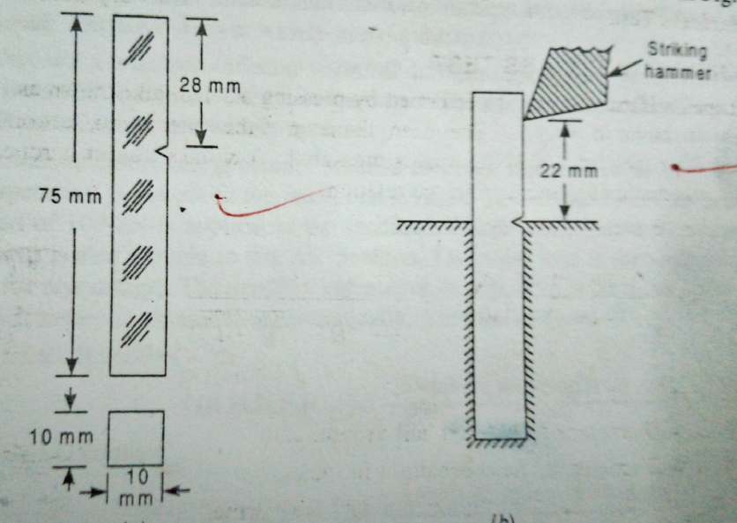

**Figure 9 Izod test**

The specimen is held vertically between two jaws in such a way that the striking hammer strikes the specimen on the face that has the notch.

The remaining procedure of obtaining the energy required to break the specimen is as in the charpy test.

**FACTORS AFFECTING IMPACT RESISTANCE**

1. Dimensions of the notch
2. Impact velocity
3. Temperature of the specimen
4. Angle and shape of notch

**CHAPTER 5**

**NON-DESTRUCTIVE TESTING**

In these tests, the specimen is not destroyed and it can be reused after test.

**TYPES OF NON DESTRUCTIVE TESTS**

1. **Visual examination**

It is done using naked eyes or with the aid of lenses or microscope. It is an easy and cheap method.

1. **Ultrasonic test**

In this test, ultrasonic radiations (i.e radiations having frequency greater than 200,000 cycles/sec) are made to fall on the material to be tested. While passing through the material, the radiations are absorbed and scattered along different directions. The radiations are attenuated (weakened) while passing through the defective area and they remain un-attenuated while passing through the perfect areas. This leads to variation in the intensity of the transmitted radiations. The received radiations are converted to an oscilloscope beam for interpretation

1. **Radiographic test**

In this test, high frequency (or short wavelength) radiations of constant intensity are made to fall on the material to be tested. While passing through the material, the radiations are absorbed and scattered along different directions. This leads to the variation in the intensity of the transmitted radiations which are usually recorded on a sensitive photographic film. The darker regions on the photographic film correspond to the defective regions and the less dark regions correspond to the perfect regions. This is due to the fact that more radiations pass through the defective areas than through the defective ones. Radiographic techniques may be broadly classified as;

* X-ray radiography
* Gamma radiography
* Neutron radiography

1. **Magnetic particle test**

In this test, the material to be tested is magnetized and then fine magnetic particles are spread over the whole surface. As the presence of a crack causes some leakage in the magnetic field, the particles will not be able to spread in the crack area but they adhere to the surrounding surface thus outlining the presence of a crack. In order to increase the visibility of a crack, fluorescent magnetic particles or ultraviolet light may be used. This method is useful for ferrous materials such as iron, steel, nickel alloys etc. The technique can only be used to detect cracks on the surface or just below it.

1. **Dye penetrant test.**

This method is used to detect cracks which extend from within a material up to its surface. A low viscosity dye is sprayed on the material to be tested. Some of the dye enters the cracks on the material through capillary action. The dye is then wiped off after some time. By observing the surface of the material, it is possible to identify areas with defects by noting areas where the dye was trapped in the cracks.

**CHAPTER 6**

**IRON CARBON DIAGRAMS**

**Introduction**

Iron is an element of great importance. Carbon is added into iron in varying amounts to produce a number of useful alloys such as mild steel, stainless steel, white cast iron, gray cast iron etc.

**Allotropy/Polymorphism**

1. Certain materials exhibit different crystal structures and physical properties at varying temperatures while possessing the same chemical behavior. This phenomenon is known as **polymorphism**.
2. If the material is an elemental solid, the phenomenon is known as **allotropy**. An example of allotropy is carbon which can exist as diamond, graphite and amorphous carbon.
3. Ceramic materials e.g., pure crystalline silica (SiO2), often exhibit polymorphism.

**Allotropic forms of pure iron**

Pure iron exist in three allotropic forms i.e., **alpha (α),** **gamma (γ)** and **delta (δ).**

1. From room temperature to **910 ˚C**, pure iron has a body-centered cubic (BCC) structure and is called **α-iron.** α-iron is ferromagnetic at room temperature but on heating to **786 ˚C,** (called curie point), the ferromagnetism disappears. The structure remains BCC.
2. Above 910 **˚C**, iron is transformed into face centered cubic (FCC) structure called **γ-iron.**
3. Upon heating to **1404 ˚C**, the **γ-iron** is transformed back to the BCC structure called **δ-iron. δ-iron** is stable up to the melting point (**1539 ˚C**) of pure iron. The BCC structure of **δ-iron** has a longer cube edge (i.e., lattice parameter) than BCC structure of α-iron.
4. The temperatures at which structural changes take place are called **critical points** or **arrest points**. The critical points correspond to temperatures **910 ˚C** and **1404 ˚C.**

**IRON CARBON SYSTEM**

1. It is the most important binary system in engineering alloys. The alloys of iron-carbon system containing **0 to 2%** carbon are called **steels**. Those containing from **2% to 6.7%** are called **cast irons**.
2. However in practice, the steels are manufactured with carbon content up to **1.4%** due to the fact that steels with carbon content more than 1.4% **are brittle** and hence **are not useful**. Similarly, the cast irons that are manufactured in practice contain carbon from **2.0% to 4.5% only**.

**PHASE DIAGRAM OF IRON-CARBON SYSTEM**

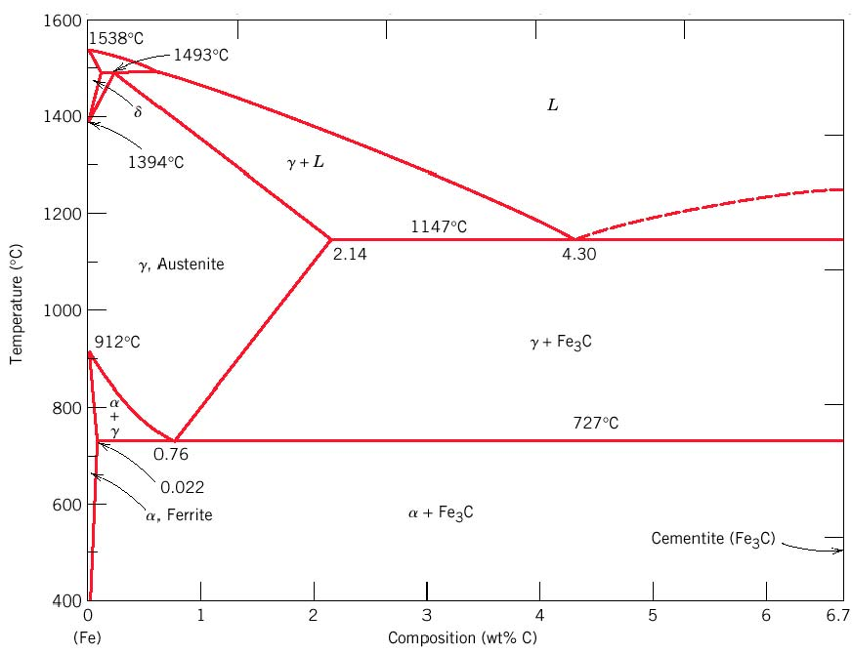

**Figure 1: Iron-iron carbide phase diagram**

* In this diagram, the carbon composition (weight per cent) is plotted along the horizontal axis and the temperature along the vertical axis.
* The diagram shows the phases present at various temperatures for **very slowly cooled iron-carbon** alloys with carbon content up to 6.7%.
* The low carbon region around 1400**˚C** in the phase diagram is not of any practical importance. However the region lying in the 700-900**˚C** temperature range and 0-1% carbon range is the most important region in the phase diagram. In this region, an engineer can develop within steel, those microstructures which are required for desired properties.

**SOLID PHASES IN IRON-IRON CARBIDE PHASE DIAGRAM**

**α-ferrite:** It is a **solid solution** of carbon in iron. It is also known as **ferrite**. Has a **BCC** structure. At 0% carbon it corresponds to α-iron. Maximum solubility of carbon in α-iron is 0.022% at 727 **˚C.** The solubility of carbon in α-ferrite decreases with decrease in temperature until it is about 0.008% at 0 ˚C. The carbon atoms, because of their small size are located in interstitial spaces/voids in the crystal lattice. α-ferrite is **soft**, **ductile** and **highly magnetic**.

**Austenite:** It is a **solid solution** of carbon in **γ-iron.** It has an **FCC** structure and has a much greater solid solubility for carbon than α-ferrite. The solubility of carbon in austenite reaches a maximum of 2.14% at 1147 ˚C and then decreases to 0.76% at 727˚C. The carbon atoms are dissolved interstitially but to a much greater extent than in α-ferrite. Austenite is **soft** and **ductile**. It is **not ferromagnetic** at any temperature.

**Cementite:** It is an **intermetallic iron-carbon compound**. Also called iron carbide. Its chemical formula is Fe3C. It contains 6.7% carbon and 93.3% iron. As compared to austenite and ferrite, it is extremely **hard** and **brittle**. It **is magnetic** *below* 210˚C.

**δ-ferrite:** It is a solid solution of carbon in δ-iron. It has a BCC crystal structure but with a different lattice parameter (length of the unit cell) to α-ferrite. The maximum solid solubility of carbon in δ-ferrite is 0.09% at 1493˚C.

**NB:**

1. With the addition of carbon to iron, the critical points vary with the composition of carbon in iron.
2. The critical temperature corresponding to the horizontal line at 727˚C is called **lower** critical temperature.

**EUTECTOID, HYPOEUTECTOID AND HYPEREUTECTOID STEELS**

1. Iron-carbon alloys containing carbon from 0 to 1.4% are called steels. These steels are quite often referred to as plain carbon steels when they do not contain any alloying element.
2. A plain carbon steel **containing 0.8%** carbon is known as **eutectoid steel**
3. If the carbon content of the steel is **less than 0.8%,** it is called **hypoeutectoid steel**. Most of the steels produced commercially are hypoeutectoid steels.
4. The steels which contain **more than 0.8%** carbon are called **hypereutectoid steels**.

**CHAPTER 7**

**HEAT TREATMENT**

The heat treatment process comprises of;

* Heating the metal to a specified temperature
* Holding the metal at increased temperature for a specified period
* Cooling the metal according to the process requirements

**OBJECTIVES OF HEAT TREATMENT**

1. To soften the metal
2. To relieve internal stresses which are set up within the metal due to cold or hot working
3. To improve hardness of the metal surface
4. To improve machinability
5. To refine grain structure
6. To improve mechanical properties like tensile strength, ductility, shock resistance etc
7. To improve electrical and magnetic properties
8. To increase resistance to wear, tear, heat and corrosion

**TYPES OF HEAT TREATMENT**

* Normalising
* Annealing
* Spheroidising
* Hardening
* Tempering
* Carburising
* Nitriding
* Cyaniding
* Induction hardening
* Flame hardening

**COMPARISON BETWEEN HARDNESS AND HARDENABILITY**

**Hardness** is the property of a material by virtue of which it is able to resist abrasion, indentation and scratching by hard bodies. It is a surface property and can be measured by methods like Brinell’s, vicker’s, Rockwell’s, Knoop’s etc

**Hardenability** is the susceptibility of a material to get hardened. It is affected by the composition of an alloy, its percentage contents and the grain size.

**NORMALISING**

**Objectives of normalising**

1. To refine the grain structure of the steel and to improve machinability, tensile strength and structure of the weld
2. To remove strains caused by cold working processes like hammering, rolling, bending etc., which makes the metal brittle and unreliable
3. To remove dislocations caused in the internal structure of the steel due to hot working
4. To improve certain magnetic and electrical properties

**Normalising procedure**

The process of normalising consists of heating the steel 30◦C to 50◦C above its upper critical temperature for hypo eutectoid steel or (Acm) line for hypereutectoid steel. It is held at this temperature for about 15 minutes and then allowed to cool down in still air.

**Effects of Normalising**

The process provides a homogenous structure consisting of ferrite and pearlite for hypo eutectoid steels, and pearlite and cementite for hypereutectoid steels. The homogenous structure provides a higher yield point, ultimate tensile strength and impact strength with lower ductility to steels.

**FULL ANNEALING**

**Objectives of full annealing**

* To soften the metal
* To refine its grain structure
* To relieve stresses
* To remove gases trapped in the metal

**Full annealing procedure**

The process consist of heating the steel 30◦C to 50◦C above the upper critical temperature for hypoeutectoid steel and by the same temperature above the lower critical temperature for hypereutectoid steels. The steel is then held at this temperature for some time to enable the internal changes to take place. The time allowed is approximately 3-4 minutes for each millimeter of thickness of the largest section, and then slowly cooled in the furnace.

The rate of cooling varies from 30◦C to 200◦C per hour depending upon the composition of steel. The objects may also be taken out of the furnace and cooled in ashes to prolong the cooling time.

In order to prevent decarburization of the steel is packed in a cast iron box containing a mixture of cast iron borings, charcoal, lime, sand or ground mica. The box along with its contents is generally allowed to cool slowly in the furnace after the proper heating has been completed

**SURFACE HARDENING OF STEEELS**

Surface hardening of steels is important because it imparts desirable properties to the material. The surfaces are hardened to resist wear and tear. At the same time care is taken to ensure soft and tough interior that is able to absorb any shocks. Examples of case hardening; Carburizing, Cyaniding, Nitriding

**Heat treatment defects**

* Warping
* Charring
* Residue stress
* Distortion

**CHAPTER 8**

**CERAMICS**

The term ceramics is used to denote those products which are made from inorganic materials and have non-metallic properties. Ionically bonded magnesia (MgO) and covalently bonded silicon carbide are some simple examples of ceramics. Examples of traditional ceramic materials are stone, brick, concrete, clay, glass, vitreous enamel and refractories.

**CLASSIFICATION OF CERAMICS**

On the basis of applications, ceramic materials can be classified into the following six groups;

* Glasses
* Clay products
* Refractories
* Abrasives
* Cements
* Advanced materials

1. **Glasses**

Glasses are non-crystalline silicates containing oxides such as CaO, Na2O, K2O and Al2O3. Typical applications of glasses include containers, windows, lenses and fibre glass.

1. **Clay products**

Clay products may be broadly classified into the following two categories

* **Structural clay products:** These include bricks, tiles and sewer pipes
* **White wares:** These include porcelain, pottery, table ware, china and sanitary ware

1. **Refractory materials**

These are the ceramic materials that are capable of withstanding high temperatures without appreciable deformation under service conditions. For example, magnesia (with a melting point of 2852˚C) and alumina (with a melting point of 2040˚C). Such materials are used for lining of high temperature furnaces, boilers, crucibles, converters and supports for hot wires. Other common examples of refractory materials are silica, magnesite, dolomite, silicon carbide, zircon and graphite.

**PROPERTIES OF REFRACTORY MATERIALS**

1. They do not fuse or soften at the temperatures at which they are used.
2. They have excellent resistance against thermal shock (i.e sudden changes in temperature) and abrasion.
3. They do not crumble or crack under the prevailing pressure when in use at high temperatures
4. They have low coefficient of thermal conductivity
5. They have high resistance to corrosion and therefore they do not react chemically with the molten metal or slag in the furnace
6. They are impermeable to gases and liquids
7. They have extremely low values of electrical conductivity
8. **Abrasives**

These ceramic materials are used to wear, grind or cutaway other materials. Hence they have a very high hardness or wear resistance and toughness. Examples include silicon carbide, tungsten carbide, aluminium oxide and silica sand.

1. **Advanced ceramics**

Applications:

* In optical fibre communications
* In micro-electro-mechanical systems
* As ball bearings
* In light bulbs and lamps
* Dies for continuous casting
* Rocket nozzles
* Heat exchangers for chemical industries

**CHAPTER 9**

**POLYMERS**

(In Greek, Polus = many & mer = unit)

A polymer is composed of a large number of repetitive units called monomers or simple molecules. (In Greek, mono =one). Thus a polymer is made up of thousands of monomers joined chemically together to form a large molecule. Each molecule of a polymer is either a long chain or a network of repetitive units or monomers.

**DEFINITIONS**

**Polymerization:** It is the process of forming a polymer

**Degree of polymerization:** It is the number of repetitive units (or mers) present in one molecule of a polymer.

Mathematically,

**Linear polymer:** It is a polymer that is obtained by simply adding the monomers together to form **long** chains

**Copolymer:** It is a polymer which is obtained by adding different types of monomers

**Branched polymer:** It is a polymer which is obtained by connecting side branches to the main one

**Cross-linked polymer:** It is a polymer which is obtained by connecting the long chains through a covalent bond

**ADDITION TO POLYMERS**

In most cases, it becomes very essential to add some extra materials into the monomers before or during the process of polymerization in order to impart certain desired properties to the polymers. The various substances which are usually added into the monomers are:

1. **Plasticizers:** They act as internal lubricants and prevent crystallization by keeping the chains separated from one another
2. **Fillers:** They are added to improve strength, dimensional stability and heat resistance. Examples include wood, asbestos, glass, fibres, mica and slate powder
3. **Catalyst:** Are added to expedite as well as complete the polymerization reaction. Are also called accelerators or hardeners
4. **Initiators:** Are added to initiate the reaction among monomers and to stabilize the end reaction of the molecular chains. Example is hydrogen peroxide (H2O2)
5. **Dyes and pigments:** These are added to impart the desired colour to the finished polymers

**TYPES OF POLYMERIZATION**

1. **Addition polymerization**

This is the process in which two or more chemically similar monomers are polymerized to form long chain molecules. It takes place in unsaturated organic compounds. E.g Ethene forms polyethene and vinyl chloride forms PVC.

1. **Condensation polymerization**

This is the process through which two or more chemically different monomers are polymerized to form a cross linked polymer along with a by-product such as water or ammonia. It takes place in unsaturated organic compounds and requires suitable conditions such as high pressure, temperature and presence of a catalyst. Example is, methyl alcohol (CH3OH) and acetic acid (CH3COOH) condenses to form an ester with water as a by product

**PLASTICS (RESINS)**

A plastic may be defined as an organic polymer which can be moulded into any desired shape and size with the help of heat, pressure or both. The plastic in its liquid form is known as resin. Natural plastics do not find much importance in actual practice and it is only synthetic plastics which have many applications.

**Types of synthetic plastics**

1. **THERMOPLASTICS**

Thermoplastic resins are the polymers whose plasticity increases with the increase in temperature. E.g, polyethylene, polystyrene, vinyl polymers, amides, acrylics e.tc.

Most thermoplastics are formed by **addition** polymerization. Addition polymerization produces chain / linear molecules and therefore thermoplastics can be mechanically deformed and softened at high temperatures. They can easily be moulded or extruded due to the absence of cross links. On cooling they regain their original low temperature properties but they retain their shape and size into which they were moulded. A brief description of some thermoplastics is given below;

* **Polyethylene (polythenes)**

Are produced by polymerizing **ethylene** molecules. They **have excellent electrical insulation** properties and are **widely used as** insulating coatings for electrical wires, films, sheets, pipes bottles, buckets etc.

* **Polystyrenes**

Are produced by polymerizing **styrene.** They have excellent **dielectric** properties and high **resistance to chemicals**. They are **widely used as** refrigerator door liners, hot drink cups, radio and television cabinets, food containers etc.

* **Polyvinyls**

Are produced by polymerizing **vinyl compounds**. They **have** good electrical insulation resistance, low flammability and toughness. They are **widely used to** manufacture rain coats, handbags, lead wire insulation vinyl flooring etc.

1. **THERMOSETTING PALSTICS (THERMOSETTING RESINS)**

Are the polymers which do not deform on mechanical stressing. E.g, polyester, phenolics, urea formaldehyde, epoxides etc. They are produced by condensation polymerization. Condensation polymerization produces cross linked molecules and therefore thermosetting plastics cannot be softened once they are moulded, even at high temperatures. i.e their plasticity does not increase with temperature. As a result they cannot be remoulded into any new shape.

**COMPARISON BETWEEN THERMOPLASTICS AND THERMOSETTING PLASTICS**

|  |  |  |
| --- | --- | --- |
| **S. No** | **THERMOPLASTICS** | **THERMOSETTING PLASTICS** |
| 1 | Are composed of chain molecules | Are composed of cross-linked molecules |
| 2 | Are produced by addition polymerization | Are produced by condensation polymerization |
| 3 | Can be mechanically deformed and softened at high temperatures | Cannot be mechanically deformed and softened at high temperature |
| 4 | Their plasticity increases with increase in temperature | Their plasticity does not increase with the increase in temperature |
| 5 | They can easily be moulded and remoulded into any shape | They cannot be remoulded into any new shape |

**RUBBER**

Rubber may be defined as an organic polymer which elongates on stretching and regains its original shape after the removal of the stress. A major portion of the rubber is consumed in manufacture of tyres and tubes for vehicles.

**TYPES OF RUBBERS**

1. **Natural rubber**

Natural rubber is of the following types;

* Chlorinated rubber
* Cyclised rubber
* Rubber hydrochloride

1. Synthetic rubbers (Elastomers)

Are manufactured from raw materials such as coke, limestone, petroleum, natural gas, salt, alcohol, sulphur, ammonia, coal tar etc. Synthetic rubbers or elastomers are not exactly a structure like that of natural rubber but they are rubber like materials which have many properties like those of natural rubber. Moreover, some of the synthetic rubbers resemble with the natural rubbers in their chemical structure.

**VULCANIZATION:** It is the process of heating the rubber compound with **sulphur.** After vulcanization;

* The rubber becomes less sensitive to changes in temperature
* The rubber acquires increased elasticity and tensile strength
* The rubber is more durable when exposed to weather
* The rubber is more resistant to chemical reagents

**CHAPTER 10**

**CORROSION**

Corrosion is the destruction (or deterioration) of a metal and unwanted chemical or electrochemical attack, by its environment starting at the surface. The corrosion of a metal is sometimes regarded as a process reverse to that of producing metal from its ore. The two most familiar examples of corrosion are the rusting of iron and the formation of green film on the surface of copper.

The annual loss to the whole world through the corrosion of different materials is **more than 2 billion dollars**. As a result of this colossal loss, research and development work of corrosion process and the means of its prevention are of great importance to the scientists and engineers these days.

**Electrode potential:** This is an important term in the field of corrosion which signifies the rate at which the corrosion is taking place. **Electrode potential may be defined** as the voltage developed at an electrode, with reference to a standard electrode. It depends on;

* Nature of the metal
* Nature and concentration of solution

**Galvanic series**:

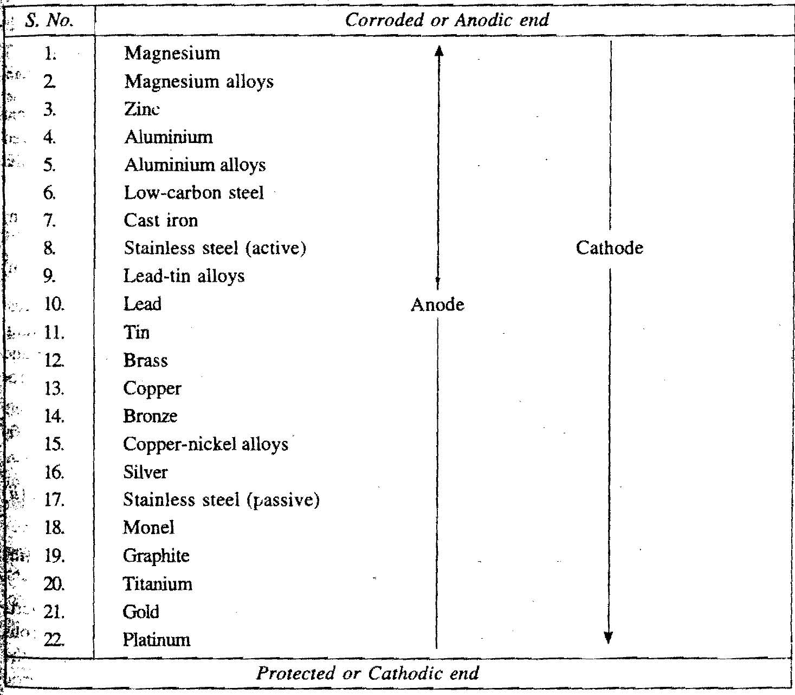

The electrode potential of various metals and alloys in common use has been measured by immersing them in sea water. The values so obtained are arranged in the decreasing order of their activity. The metals or alloys arranged in this order constitute a galvanic series. The galvanic series provide more accurate information regarding the relative tendency of common metals and alloys to undergo corrosion.

**CLASSIFICATION OF CORROSION**

1. **Direct chemical corrosion (Dry corrosion)**

This is the corrosion that involve direct combination between metals and dry gases.Chemical reactions of dry chlorine, hydrogen sulphide, oxygen etc with dry metal are few examples of direct chemical corrosion.

1. **Electrochemical corrosion (wet corrosion)**

This is the type of corrosion which involves the flow of electric current between two dissimilar metals.

Passivity: It is a phenomenon in which a metal or an alloy exhibits a much higher corrosion resistance than expected from its position in the electrochemical or galvanic series. It is as a result of formation of a highly protective, but very thin and quite invisible film on the surface of a metal or an alloy, which makes it more noble (or inactive). This film is insoluble, non-porous and of a self-healing nature. When the film is broken, it repairs itself on exposure to oxidizing conditions. Titanium, aluminium, chromium and a variety of stainless steels (containing chromium) are the commonly known metals and alloys which are considered to be passive.

**TYPES OF CORROSION**

1. **Uniform corrosion**

It is a type of corrosion which occurs where metal or alloy is completely homogenous (i.e., of the same nature both chemically and mechanically).

1. **Stress corrosion (Stress corrosion cracking)**

It is a type of corrosion which occurs in internally stressed engineering components used in corrosive environments. It is prevented by either the removal of the stresses or removal of the corrosive medium.

1. **Intergranular corrosion**

It is a type of corrosion which occurs along grain boundaries of a metal sensitive to corrosive attack.

1. **Pitting corrosion**

It is a type of corrosion which takes place at a particular point like a pin hole, thus forming a cavity on the metal surface. The pin hole penetrates deep into the metal and the corrosion product comes out as shown below.

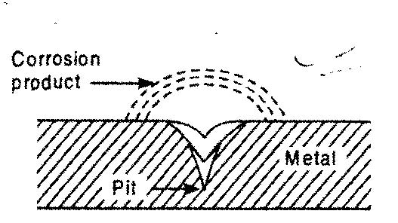

1. **Season corrosion**

It is a type of corrosion which occurs in brass especially in the presence of moisture and traces of ammonia.

1. **Crevice corrosion**

It is a type of corrosion which occurs in cracks or crevices formed between mating surface metal assemblies and takes the form of pitting or etched patches. The mating surfaces may be of similar metals, a metal and a non-metal, or dissimilar metals.

1. **Fatigue corrosion**

It is a type of corrosion which occurs in components which are subjected to cyclic stresses. It may be prevented by avoiding the presence of crevices between adjacent parts of the structure or treatment of the corroding medium.

1. **Erosion corrosion**

It is a type of corrosion that is caused by the combined effect of erosion by the turbulent flow of gases or liquids and the rubbing of solids over a metal surface.

1. **Atmospheric corrosion**

It is a type of corrosion which occurs either due to oxide film formation or due to the film breakdown on the metal surface. The factors which greatly affect the atmospheric corrosion are humidity, presence of impurities in the atmosphere, nature of corrosion products and the presence of suspended particles in the atmosphere.

1. **Underground corrosion**

It is a type of corrosion which occurs in the pipes burried under the earth’s surface. It depends on the corrosive nature of the soil.

1. **Fretting corrosion**

It is a type of corrosion which occurs in situations where there is slight relative movement of contacting surfaces due to the action of an alternating load. It occurs more frequently in bolted joints and other fitted assemblies.

1. **Selective corrosion**

It is a type of corrosion which occurs in alloys in which one component is removed selectively, leaving behind the other.

**PREVENTION AND CONTROL OF CORROSION**

The following methods are generally used to prevent or control corrosion of metals;

1. Alloying of metals
2. Heat treatment of metals
3. Use of cathodic protection
4. Suitable design and fabrication procedure
5. Use of inhibitors
6. Modification of the corrosive environment
7. Use of protective coatings (i.e., metallic or non-metallic)

**SUITABLE DESIGN AND FABRICATION PROCEDURE**

Corrosion maybe prevented (or minimized) by selecting a suitable design and fabrication procedure for a particular shape of a component. The selection of a material for a component should be such that:

* The use of dissimilar metals is minimized to prevent galvanic corrosion. If the use of dissimilar metals is essential, the metals selected should have their electrode potential as close as possible to each other.
* The design procedure should avoid the presence of cracks
* Welded joints should be preffered over riveted joints to prevent stress corrosion
* Sharp corners and recesses should be avoided as they give rise to the formation of stagnant areas and accumulation of solids

**USE OF INHIBITORS**

An inhibitor is a substance which is added in a small quantity in the electrolyte to reduce the rate of corrosion. The inhibitors may be organic or inorganic and should be able to dissolve in the corroding medium. Moreover they should be able to form a protective layer of some kind. Examples of inhibitors are chromates, phosphates, magnesium and calcium salts.

**MODIFICATION OF CORROSIVE ENVIRONMENT**

The rate of corrosion may be greatly reduced by small changes in the corroding environment. E.g., changes in composition, nature and temperature. A small decrease in temperature causes an appreciable decrease in the rate of corrosion. Removal of dissolve gases also help in reducing the rate of corrosion.

**USE OF PROTECTIVE COATINGS**

Protective coatings maybe broadly classified into the following two categories:

1. **Non-metallic coatings**

Examples of these coatings are:

* Paints and lacquering
* Plastic coatings
* Vitreous coatings
* Oxide coatings

1. **Metallic coatings**

They include:

1. **Electroplating**

It is a process of depositing a very thin layer of metal coating on the base metal by passing a direct current through an electrolyte solution containing some salt of the coating metal.

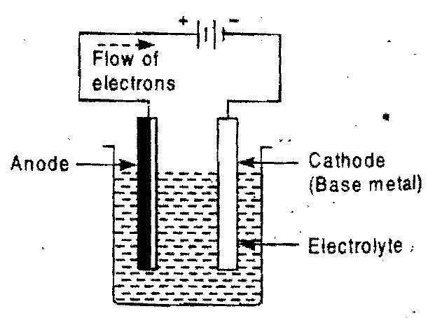

The base metal is made is made to act as a cathode whereas the coating metal as an anode. Direct current is passed for a known time to obtain a coating of desired thickness. The commonly used metals which are used for protective coating are copper, nickel, silver, gold, chromium, cadmium and tungsten.

1. **Dipping**

In this process, the component to be coated is dipped in a bath of molten metal. The component is then taken out from the bath and finished properly. The most common processes of dipping are **galvanizing** and **tinning**.

1. **Spraying**

It is a process of providing a thin coating by depositing an atomized metal on the surface of the base metal

1. **Cladding**

It is a process of providing a comparatively thicker layer of coating on the metal surface. It is usually done by a process called hot rolling.

1. **Cementation**

It is a process of providing a thin layer of powdered metal coating on the base metal surface. The temperature two which the base metal and the metal powder are heated is always more than the melting temperature of the coating metal.

**CHAPTER 11**

**COMPOSITES**

A **composite** is formed when two or more materials are combined together to produce a new material which possesses much superior properties than any one of the constituent materials. An example of a natural composite material is wood, which consists of long cellulose fibre held together by amorphous lignin. Some of the artificial (or synthetic) composite materials are cement concrete, glass reinforced plastic, plywood etc.

**TYPES OF COMPOSITE MATERIALS**

1. Agglomerated materials
2. Laminated materials
3. Reinforced materials

**AGGLOMERATED MATERIALS**

These are materials in which, particles are condensed together to form an integral mass. A common example of agglomerated materials is cement concrete which is formed by mixing coarse aggregate, fine aggregate, cement and water in different proportions. Another useful agglomerated material is grinding wheel which is made by mixing asphalt, stone and resin in different proportions. Some other useful agglomerated materials are cemented carbide tools and ceramics.

**LAMINATED MATERIALS (OR LAMINATES)**

These are the materials which are produced by bonding two or more layers of different materials completely to each other. The materials constituting a laminated material may be metallic or non-metallic depending upon the type of application. The common examples of laminated materials are plywood, tufnol, sunmica, linoleum etc. In laminated materials, the top most layer provides the desired appearance and workability while the lower layers contributes to its strength.

**REINFORCED MATERIALS**

These are the materials which are produced by combining some suitable materials to provide additional strength which does not exist in a single material. Examples of reinforced materials are;

1. **Reinforced cement concrete**

It is produced by placing steel rods (i.e reinforcement bars) in the cement concrete mixture

1. Nylon reinforced rubber
2. **Glass-fibre reinforced plastic**

It is produced by combining glass fibre with plastic. In this composite material, the glass provides the necessary strength and the plastic reduces brittleness. The fibres can be employed in the form of continous lengths, staples or whiskers.

The following three conditions are essential to prepare a glass-fibre reinforced plastic material:

* The coefficient of expansion of the fibre should match closely to that of the plastic material
* The fibre and the plastic material should be chemically compatible with each other to avoid any undesirable reaction
* The fibre should be stable at room temperature and should retain its strength at high temperature.

**Example:**

Determine the volume ratio of aluminium and boron in aluminium-boron composite which can have the same Young’s modulus equal to that of iron. The Young’s modulus of Aluminium, iron and boron are 71, 210 and 440 GN/m2 respectively.

**Solution:**

Given, YAL = 71GN/m2  YFE = 210GN/m2  YB = 440GN/m2

Let VAL= Volume fraction of Aluminium in the composite

VB= Volume fraction of Boron in the composite

VB + VAL = 1 ………………………………………. (1)

YFE = VAL . YAL  + VB .YB

210 = 71 VAL + 440 VB …………………………....... (2)

Solving equation (1) and (2) simultaneously,

VAL= 0.623 and VB = 0.377